Chapter 11, Problem 14.

Using Fig. 11.45, design a problem to help other students to better understand maximum average power transfer.
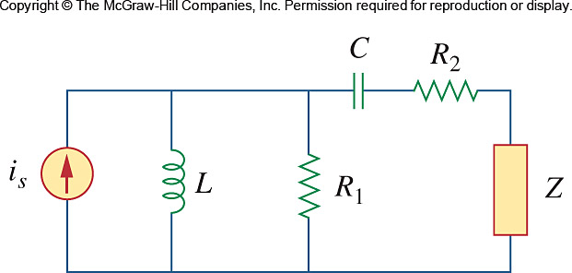

Figure 11.45
For Prob. 11.14.

